|  |  |
| --- | --- |
| IMAGE PROCESSING: User Manual  Final Revision 05.01.14 | LAUDED llamas  Simbarashe Musarurwa Kistel Hazel Danya Bynoe Matthew Aaron Michael Grayson  Software Engineering  CMPS 4113 |

Contents

Welcome

1. Introduction………………………………………………………………………………………………………………………………….3
   1. Purpose of Document……………………………………………………………………………………………………………3
   2. Purpose of Software………………………………………………………………………………………………………………3
   3. Applicability ………………………………………………………………………………………………………………………….3
   4. Users……………………………………………………………………………………………………………………………………..3
2. Installation…………………………………………………………………………………………………………………………………….3
   1. System Requirements…………………………………………………………………………………………………………….4
   2. System Installation…………………………………………………………………………………………………………………4
3. Getting Started……………………………………………………………………………………………………………………………..4
   1. Running Application……………………………………………………………………………………………………………….4
   2. Navigating the User Interface…………………………………………………………………………………………………4
4. Processing Images………………………………………………………………………………………………………………………….5
   1. Selecting the Base Image………………………………………………………………………………………………………..5
   2. Selecting Images to be Processed…………………………………………………………………………………………..6
   3. Output Data …………………………..………………………………………………………………………………………………8
   4. Manipulating the output file………………………………………………………………………………………………….10
5. Conclusion…………………………………………………………………………………………………………………………………….10

# 1. Introduction

### 1.1 Purpose of Document

The purpose of this document is to provide the users of the image processor with information on how to install, run, use and possibly troubleshoot the provided software.

### 1.2 Purpose of Software

This software seeks to drastically minimize the complexity and time needed to collect data about droplets falling onto a ratcheted surface. The software encompasses the tasks that were initially performed by 3 separate applications and allows the researchers using the software to decrease to only using one application.

### 1.3 Applicability

The User manual applies only to the image processor supplied by the Lauded Llamas.

### 1.4 Users

The users of this document will be researchers involved in tracking the motion of a droplet as it falls onto a ratcheted surface. The group of researchers who will be using this software includes but is not limited to: Dr. Ok and Dr. Guo.

# 2. Installation

Informs users on what is needed and how to install the application.

### 2.1 System Requirements

Before installing the Image processor please ensure that your system meets the following requirements.

1. Windows 7 Professional or better
2. Excel or spreadsheet application

### 2.1 Installation Guide

1. Insert the disk into the drive
2. Copy the file labeled Image Processor onto the desktop
3. Open the Image processor file and locate ImageProcessing.exe
4. Create a Shortcut to the ImageProcessor.exe on your desktop by right clicking then sending to desktop as a shortcut
5. Double click the shortcut to run the Program

# 3. Getting Started

### 3.1 Running Application

Double click the ImageProcessor.exe icon to begin the program

### 3.2 Navigating the User Interface

### The user interface allows you to enter information as needed. There are 3 different forms that will collect information from the user. The first form will have you input the base the base image. The second form will upload the images from a folder and show the progress. The third and final form will handle the calculations and save the data.4. Processing Images

**4.1 Selecting the Base Image**

The first form after the Welcome page will look like *fig. 1*

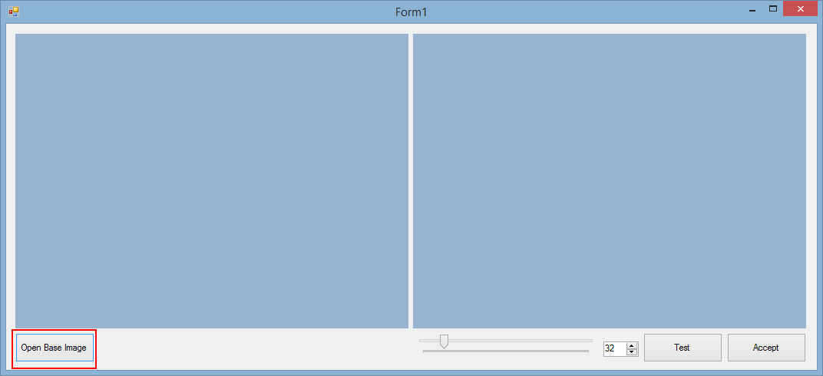

Figure 1

1. Select Open Base Image and your local documents will show up (*fig. 2*).

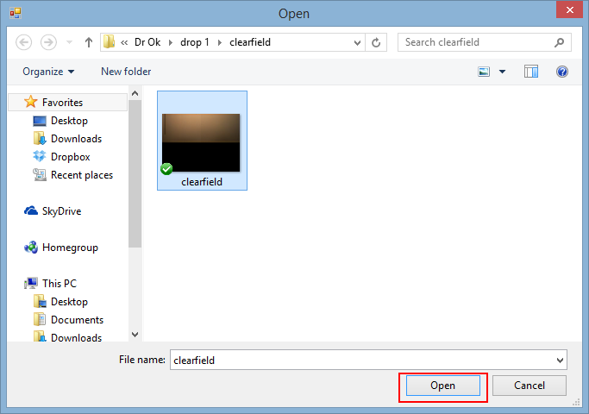

Figure 2

1. Select your base image and click open.
2. Then select Test. The image will then be converted to a black and white binary image.
3. 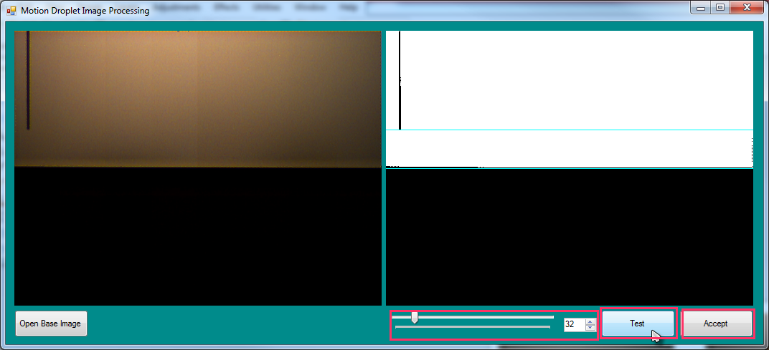Check that the binary inversion is satisfactory and that there are no artifacts in the region that is going to be processed (i.e. the blue box) (*fig. 3*)

Figure 3

1. If you are satisfied with the resulting binary image select Accept. If not use the scroll bar to adjusts the image to your satisfaction and click the Test button to check if it has adjusted accordingly

**4.2 Selecting the Images to be processed**

The following screen asks the user to input a folder. This should be a folder of images. To insert the images to be processed please follow the steps listed below.

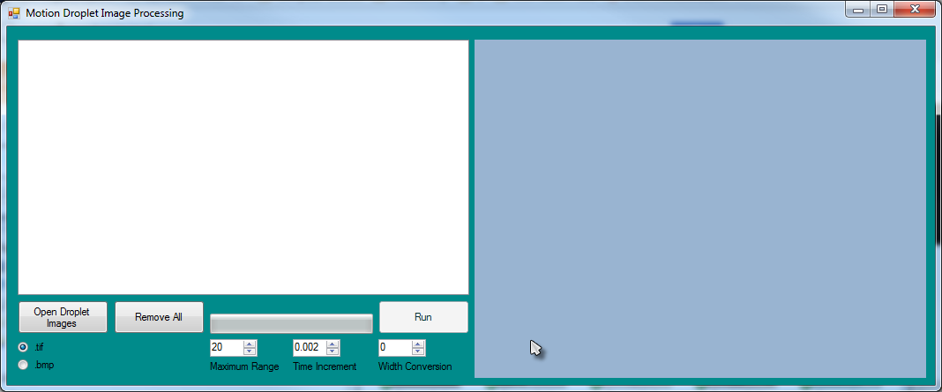

Figure 4

1. In the left corner select what image format that all the picture taken are in.
2. Select Open Droplet Images. Upon doing so this screen will pop up which says “Browse for Folder”(*fig. 5*).

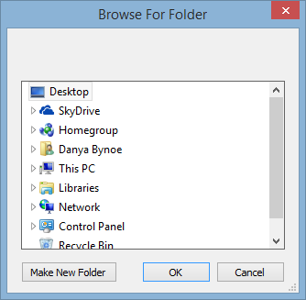

Figure 5

1. Select the folder where your droplet images are located and then select OK.   
   **N.B. Selecting invalid images i.e. non-droplet images or corrupt images, will cause the program to crash**
2. If you have selected the incorrect folder hit the button “Remove All” and repeat steps 1-2. If not move to step 5.

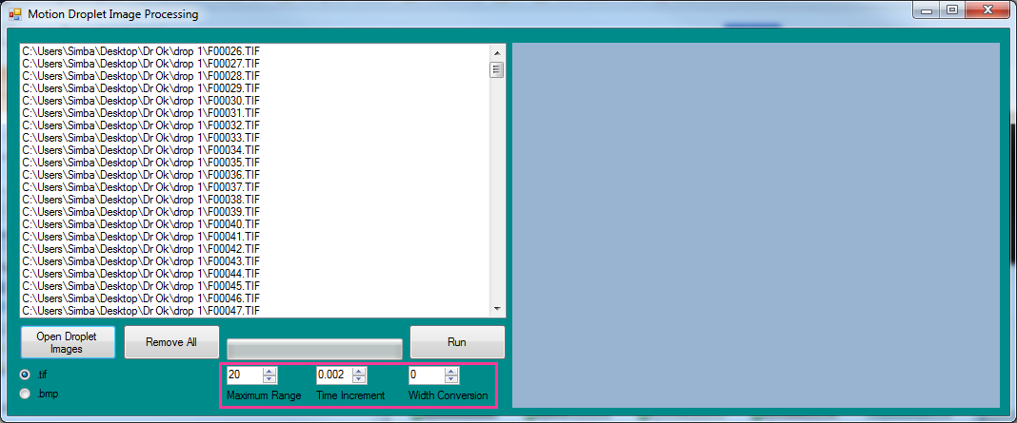

Figure 6

1. In the highlighted section of *fig. 6* some user specified values are to be entered
   1. **Maximum Range –** This applies a bounding box the designated pixel size around the detected droplet and omits any pixels outside of that bounding box from the centroid calculations. This Box should be changed depending on the size of the droplet the bigger the droplet the larger the value. A signifier of the value needs to be adjusted is if the out centroid calculations are non-uniform, or random results
   2. **Time Increment –** This is the time period between each frame in seconds e.g. if the camera captures at 1000fps then the time increment is 0.001
   3. **Width Conversion –** The distance between the furthest left point of the image and the furthest right in cm, this allows for conversion into actual metric units
2. When all parameters are fulfilled select “Run” to process those images.
3. 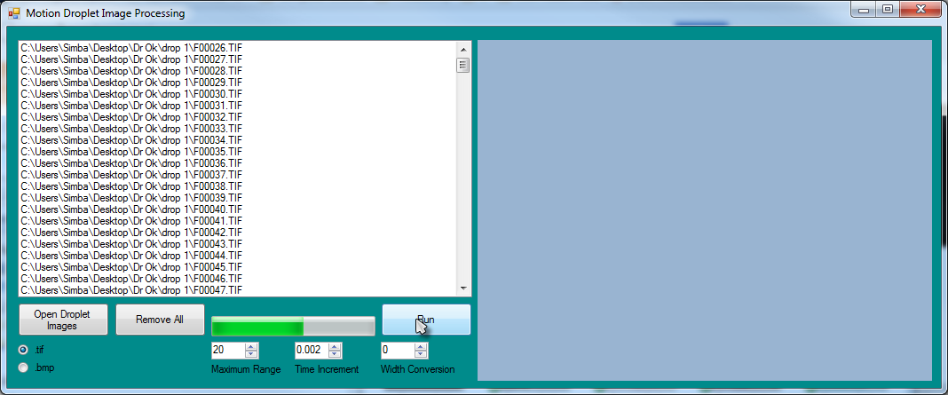As the process runs the progress bar will reflect the progress of the batch process, as shown in *fig. 7*

Figure 7

1. Once the process is complete and all images have been processed the program will revert to the Base Image selection form.

**4.3 Output Data**

Once the program has completed running it will output a comma separated value (.csv) in the parent directory of the images folder. The file name will be prefixed with the name of the folder wherein the images are found and suffixed by test as shown in the example below. In this example (fig. 8) the images were in the folder drop 1 and the csv file created was called drop 1test.csv and it was in the parent folder.

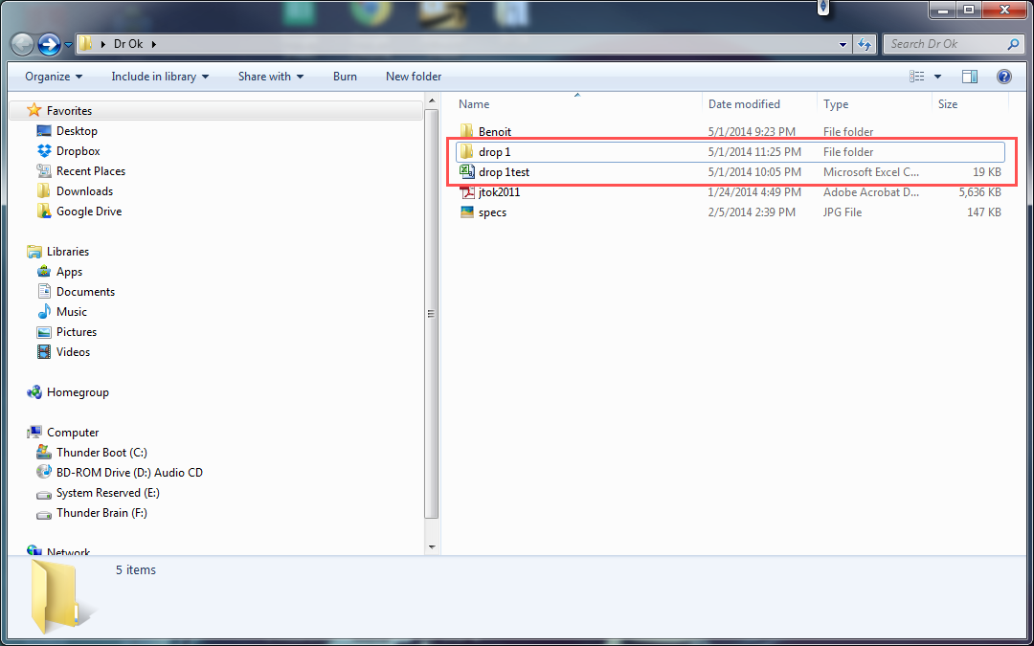

Figure 8

**Additional Output**

During the processing of the images the post-processed versions of the images are save in the same location as the original images. These images have certain attributes to them:

* They have the same name as the original file except are suffixed by bw (e.g. image1 becomes image1bw) (*fig. 9)*

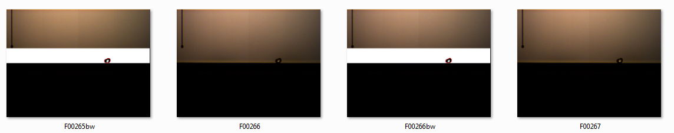

Figure 9

* They have the centroid of the image shown as a green dot and the outer part of the centroid is red pixels
* Each image maintains the binary converted section so can be used to check if the processing is functioning correctly

**4.4 Manipulating Output file**

The output file produced is readable by any spreadsheet software. To manipulate or view your results do the following:

1. Go to the location on your machine where you saved the file
2. Open the file with ‘*Excel’* or any other spreadsheet program.
3. In ‘*Excel’* you can now view and edit your file*.*
4. 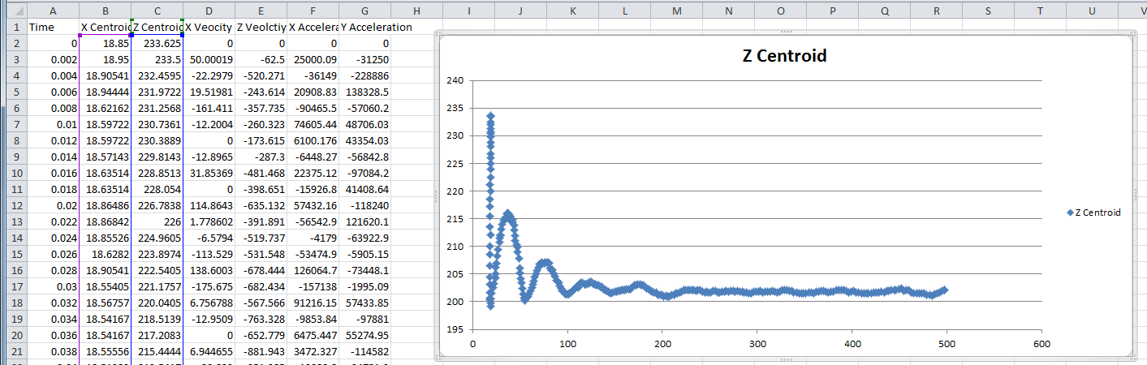Use excel to create graphs and visually analyze the data (*fig.10*)

Figure 10

**N.B. It is important that in between processing the same sets of data that the output csv file must be closed in between each batch process. Failure to do this will cause the program to crash as a result of attempting to write to a locked file**

There are some important notes for the csv output file. All values of the centroid are describing the location in terms of pixels and the same is to be said of the velocity and acceleration if there has not been any measure of the camera field-of-view.

# 5. Conclusion

The quality of results that this program produces depends heavily on the quality of the provided data. AS of now the results are as accurate as the original process but images with poor lighting and a difficult to discern droplet may suffer from erratic and inaccurate results. User must ensure that provided data is quality data, and thus the quality of the calculations will be far greater